# WEB APPLICATION USING NODE-RED :

# node-red.png

## CODE FOR GLOBAL VARIABLE NODE:

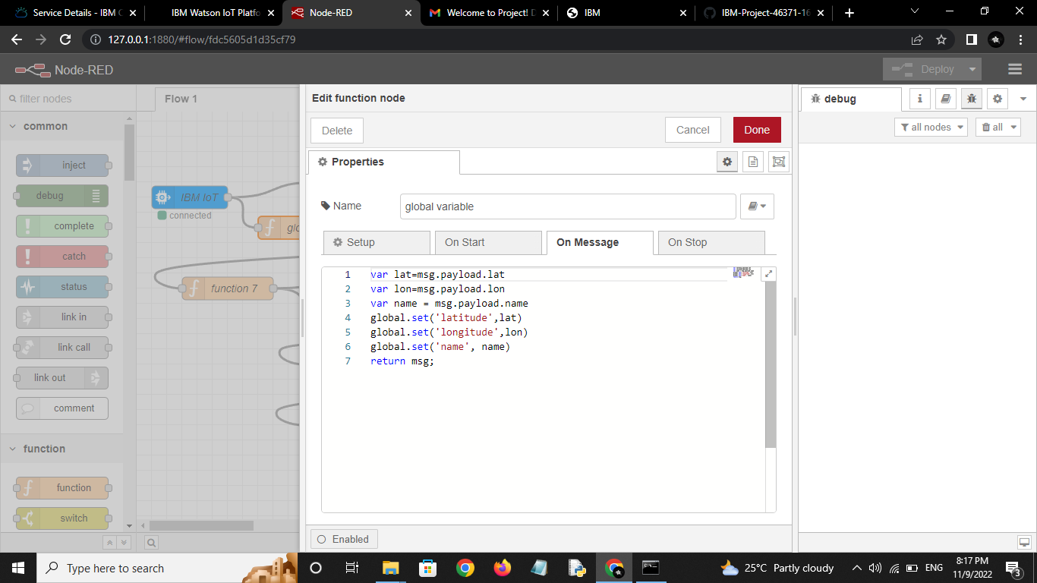

## CODE FOR FUNCTION 7 NODE:

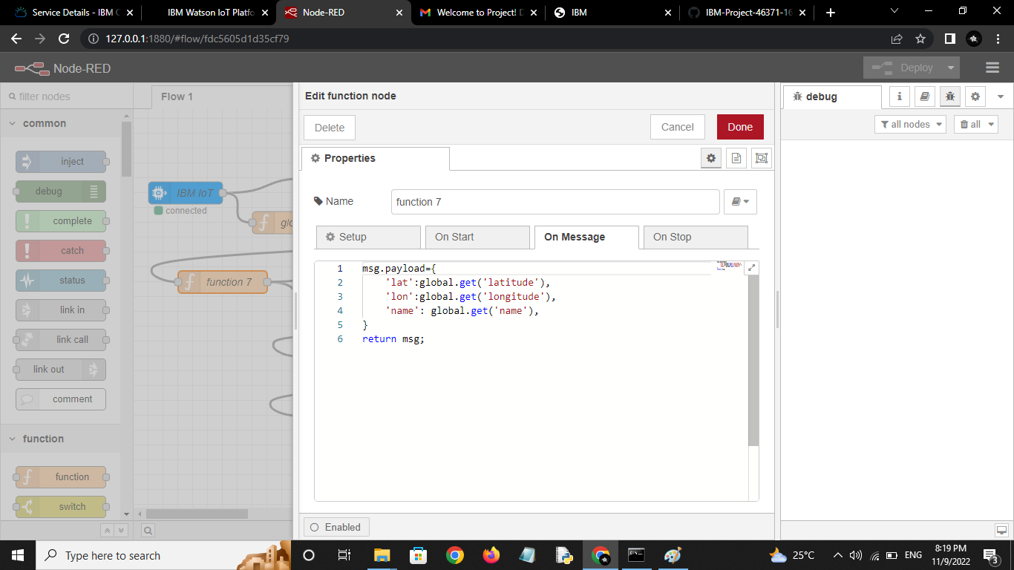

## WORLD MAP:

## world map.png

## GEO FENCE:

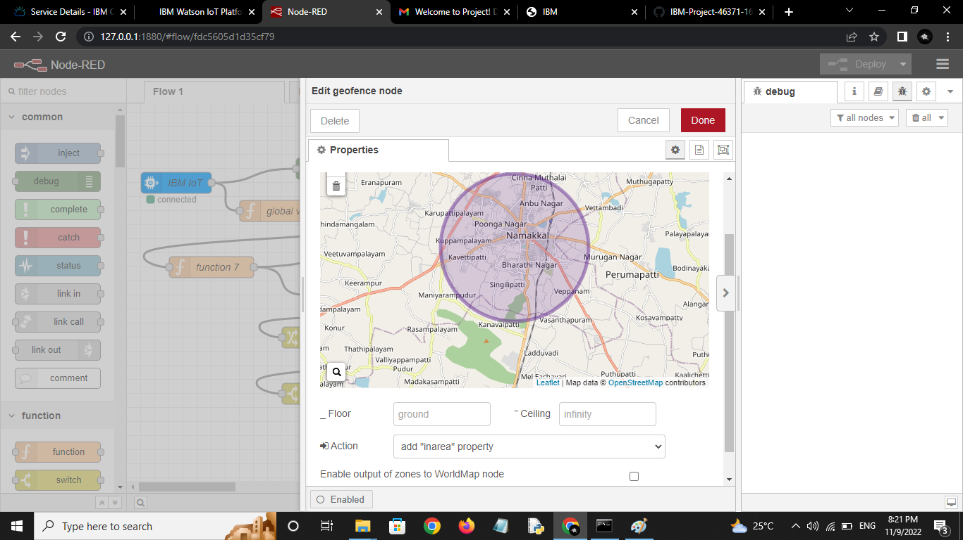

## SET.MSG.PAYLOAD:

## set.msg.payload.png

## SWITCH:

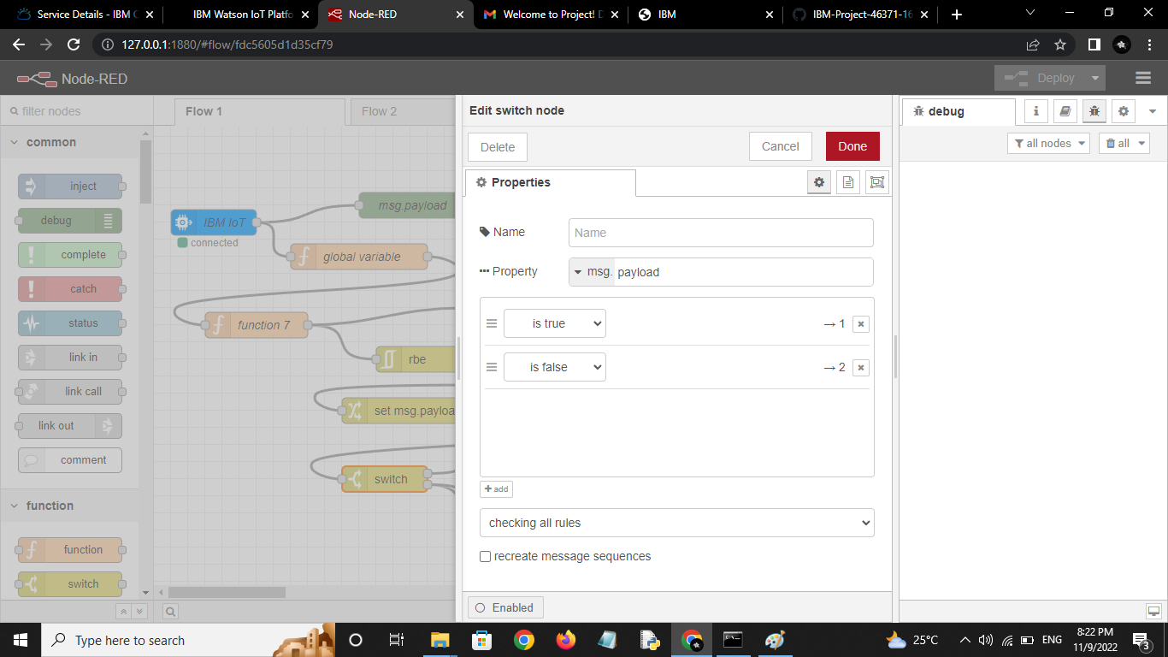

## TRUE NODE:

## true.png

## FALSE NODE:

## middle false.png

FALSE NODE:

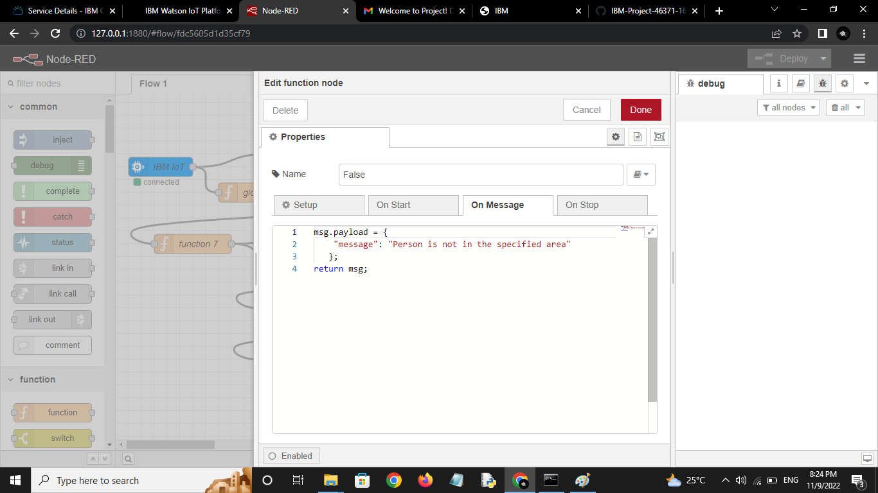

## SAMPLE NODE:

## database.png

## SHOW DIALOG NODE:

## notification.png

## HTTP REQUEST NODE:

## http.png